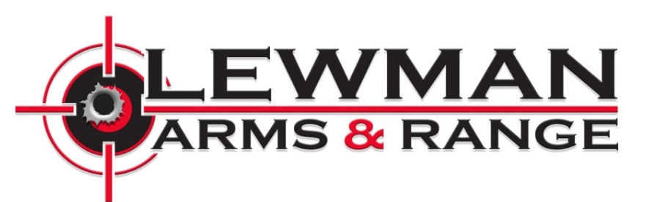

Range Rules
1) All Federal, State and Local firearm laws must be obeyed
- All shooters must be US citizens or permanent residents with accompanying driver’s licenses or green cards.
- Visitors from out of the country may only shoot rented firearms, unless accompanied by a legal resident/citizen.
2) Everyone must follow the Four Basic Rules of Firearm Safety at all times:
- Treat ALL GUNS as if they ARE LOADED.
- Never point a gun at anything you are not willing to shoot or destroy. Muzzle must always be pointed down range
- Always keep your finger straight and off the trigger until your sights are on the target and you are ready to shoot.
- Be sure of your target, what is in line with it, and what is beyond it.
3) Upon the downrange light being turned off or with the “CEASE FIRE” command from ANYONE, all shooters must STOP shooting immediately, place the firearm on the bench facing down range, and step back from the firing lane. Shooters may return to the firing lane only after the “ALL CLEAR” signal has been given.
4) All guests using the ranges must successfully complete the range safety briefing.
5) Shooters must put on appropriate eye and ear protection prior to entering the range and keep it on until they exit. LEWMAN ARMS recommends using foam earplugs in addition to over-the-ear headphone protection.
6) In an effort to maintain a safe environment, Range Master and Range Staff must be obeyed at all times.
7) Range Master and Range Staff have the right to inspect all firearms, ammunition, and equipment. Staff reserves the right to refuse usage.
8) No tobacco products of any kind including vape are permitted on the range. Food or drink are NOT permitted on the range. Animals are NOT permitted on the range.
9) No one will be permitted on the range if it is suspected that they are under the influence of alcohol, drugs, or any other intoxicating substances.
10) CLOSED TOE FLAT BOTTOM SHOES ONLY ON RANGE. TANK TOPS NOT PERMITTED. SHORTS ARE NOT RECOMMENDED FOR RANGE USE.
11) All shooting should be in a safe and controlled manner. LEWMAN ARMS does not permit “dual wielding” or “two-gun shooting” at any time. Safe controlled rapid fire (majority of rounds landing on target) is permitted until or unless it is deemed unsafe by Range Staff. No uncontrolled, rapid-fire is permitted.
12) Hand or privately loaded ammunition, tracers, explosive or armor-piercing ammunition are strictly prohibited. Shotguns are allowed with slugs or buckshot only. The ammunition types below are prohibited unless permitted by management.
- No bi-metal
- No steel inserts
- No tracers
- No armor piercing
- No Aluminum
- No birdshot
13) HANDGUNS up to .45 caliber are permitted. Firearms up to a .308 caliber round are permitted. Larger calibers may be permitted at RSO discretion based on capacity of range.
14) Lewman Arms reserves the right to eject or refuse service to anyone who inappropriately handles a firearm or would potentially endanger the safety of our patrons or staff.
15) Please ask the Range Master or Range Safety Officer for clarification if you have any questions on the Range Rules and Regulations.
16) All persons attending this facility hereby authorize consent to be photographed and release any claims against the publication of said photograph in any magazine, brochure, web presence, ad, or any other purpose as determined by LEWMAN ARMS.
IF YOU HAVE NEVER SHOT A FIREARM BEFORE, PLEASE LET US KNOW SO WE MAY ASSIST YOU.

